[1]

***Format Preparation of* International Conference on Mechanical Engineering, Material and Renewable**

First A.Author¹, Second B.Author²*,* and Third C.Author³

*Abstract*—These instructions give you guidelines for preparing papers of International Conference on Mechanical Engineering, Material and Renewable papers*.* Use this document as a template. The electronic file of your paper will be formatted further at (LJEST) Paper titles should be written in uppercase and lowercase letters, not all uppercase. Avoid writing long formulas with subscripts in the title; short formulas that identify the elements are fine (e.g., "Nd–Fe–B"). Do not write “(Invited)” in the title. Write full names of authors are required in the author field. Define all symbols used in the abstract. Do not cite references in the abstract. Do not delete the blank line immediately above the abstract; it sets the footnote at the bottom of this column.

*Key Words—*should be at least 3 to 5 keywords.

# **INTRODUCTION**

T

HIS document is a template for authors. If you are reading a paper or PDF version of this document, please download and use the electronic Microsoft Word file, so you can use it to prepare your manuscript word file. After finishing doing the format with accurate steps regarding types of lines, size of lines, spacing, adjusting figures, tables, and other details to prepare your manuscript in perfect format and view for reviewers and readers and must be in .DOC or .DOCX format.

These types of manuscript are accepted:

1. Regular Papers and Special Section papers – Four to Ten pages, including authors’ bios and photos. These will be added only on the final submission.
2. Letters – One to Three pages. Authors’ bios and photos must not be included.

The similarity check should be done by authors and this report should be uploaded along with the manuscript (similarity rate should NOT be more than **%25**).

# **Submission of a new manuscript for Review**

Contributions to the LJEST Journal must be submitted electronically on-line manuscript submission and E-mail and you should follow the journal form. Before submitting, carefully read the journal checklist and submit your manuscript accordingly. Once your paper is completely suitable to format and rules, follow this procedure:

Please use Template File and also follow instruction detailed below to prepare your manuscript:

1. **Title:**Title of paper should be written using Times New Roman and 18 punto and Blue.
2. **Author's name:**Authors's name should be written using Calibiri and 12 punto and black. Corresponding authors should have "*".
3. **Affilation:**Affilation of authors should be written down using Helvitica and 8 punto
4. **Emails:**Email and should be written using Helvitica and 8 punto.
5. **Abstract:**Abstract should be about 100-250 words and should be written using Times New Roman, 10 punto, Bold.
6. **Keywords:**Keywords should be written using Times New Roman, 10 punto, Bold and must be between 3-5.
7. **Main body of manuscript:**The main body of manuscript should be written using Times New Roman and 10 punto.
8. **Equations:**Equations should be centered in manuscript and number should be given in phrantesis.
9. **Figure and table captions:**All figure and table captions should be centered in manuscript and using Times New Roman and 8 punto and italic. (Only "figure, table" should be black).
10. **References:**All references (for paper, conference, internet, book etc) should be listed as shown in template using Times New Roman and 8 punto and should be follow *IEEE Proceedings* style references format.
11. **After finished preparation of your manuscript:** A similarity check should be done by authors and this report should be uploaded along with the manuscript (similarity rate should NOT be more than **%25**). Any program (e.g. ithenticate programme) may be used for this purposes. This is vital for ethical and Plagiarism Policy for LJEST.

Please notice that in your Author Center you may check the current status of your manuscript such as: In EIC office, Assigned to AE, AE invites reviewers, AE assigns reviewers, Under review, Awaiting AE decision, and Awaiting EIC decision. If you find that your manuscript is not moving in the process for a month or more please contact the Editor-in-Chief.

# **TIE checklist for manuscript submissions**

Authors should consider the following points before submitting a new paper. Otherwise the submission would be automatically rejected.

1. New manuscripts cannot exceed 10 pages (3 for letters). Only a very limited overlength (1/2 page at most) is tolerated. Note that usually in the review process the reviewers tend to ask for more explanations, also note that the maximum allowed length is 10 pages on initial/first submission. Note that in the final page count, the authors’ bios and photos should be included.
2. If a significant portion of your manuscript was already published at a conference you must submit use our "Post Conference Papers" template. The manuscript must include the previous work in the references section.
3. TIE policy doesn't consider surveys, state of the art papers or project reports. Only Guest Editors of a Special Section (or submissions allowed by the Editorial Board) are invited to submit such kind of manuscript. Our typical papers propose new methods and demonstrate their effectiveness through experimental results in combination with simulation results.
4. The only file that has to be submitted (uploaded) is the manuscript in PDF format (WORD files are also possible but please be sure that the file was properly converted by the submission system). In order to make it portable you must embed the not standard fonts or avoid them in the PDF file. This is not an easy process, but often all problems are solved when you are printing PDF file from WORD and you will select in printer properties “Press Quality” instead of “Standard”.
5. Manuscripts must be double column format and all other guidelines described in this document, so the length of the paper and readability of figures can be evaluated.
6. The file maximum size cannot exceed 40MB to make it accessible to our tools. Usually you will get that by adjusting the size of the figures. Note that “EPS” figures format only is required on the Final Stage.
7. Your manuscript must be within the scope of LJEST journal. If not, we will not be able to provide adequate review.
8. All cited papers must be referenced within the text of the manuscript. Be sure that the manuscript is up to date. It is expected that a significant portion of references are to recently published papers[1].
9. Your manuscript must have abstract correctly written. In the age of electronic publications it is not easy to be noticed (Industrial Electronics Society alone receives over 15,000 conference and journal papers per year). Authors have to do everything possible so the paper will be noticed and read. Therefore, very careful wording should be used in the title, abstract and index terms.
10. Your paper should describe very clearly your accomplishments so other people can understand what is your original contribution and use it. Notice that usually your technical accomplishments will be evaluated based on the number of citations but not based on the number of papers published.
11. Write clearly your manuscript. Try to keep your manuscript on the proper level from one section to another. It should be easy to understand by well-qualified professionals, but at the same time please avoid describing well-known facts (use proper references instead). Often manuscripts receive negative reviews because reviewers are not able to understand the manuscript and this is authors' (not reviewers') fault. Notice, that if reviewers have difficulties, then other readers will face the same problem and there is no reason to publish the manuscript.

# **Submission of revised manuscript for Review**

If an editor decides not to accept your manuscript, they may provide you with a decision that allows for reconsideration. and find the paper on your submission dashboard. The “Actions” column provides you with links to create a revision (for decision types of Minor Revision or Major Revision) or a resubmission (for decision types of Reject with Resubmit).

The checklist above “TIE checklist for manuscript submissions” also applies to the revised stage.

In the revision flow, the reviewers tend to ask for more explanations, also note that the maximum allowed length is 10 pages and exceptionally up to 10 pages may be authorized (paying an overlength fee). Note that in the final page count, the authors’ bios and photos will be included.

In the resubmission flow, you have to submit a new paper that is treated as a new submission (10 pages max. as new papers), this means that a new set of Associate editor and reviewers will take care of the new paper. Therefore your paper should be self-contained. No extra notes are necessary.

# **Submission of final manuscript**

If an editor decides to accept your manuscript, you will receive via email an "acceptance" decision. The status of your paper will be “Awaiting Final Files” and you will be able to submit the final manuscript.

The checklist above “TIE checklist for manuscript submissions” also applies to the final stage, with some exceptions:

1. Once you add footnotes, acknowledgement, author photos and bios, please tailor your paper so it’s length does not exceed the 10 pages limit and the last page is not half empty.
2. This submission must include the final list of references. Any later change will cause prolonged delays in the publishing process.

Upon acceptance, you will receive an email with specific instructions regarding the submission of your final files. To avoid any delays in publication, please be sure to follow these instructions. Final submissions should include source files of your accepted manuscript, high quality graphic files, and a formatted Word-DOC and PDF files. If you have any questions regarding the final submission process, please contact the administrative contact for the journal.

You are strongly encouraged to use this format file for the most accurate and efficient transfer of your manuscript, especially for those containing extensive mathematics.

# **Guidelines For Manuscript Preparation**

## Abbreviations and Acronyms

Define abbreviations and acronyms the first time they are used in the text, even after they have already been defined in the abstract. Abbreviations such as IEEE, SI, ac, and dc do not have to be defined. Abbreviations that incorporate periods should not have spaces: write “C.N.R.S.,” not “C. N. R. S.” Do not use abbreviations in the title unless they are unavoidable (for example, “IEEE” in the title of this article).

## Other Recommendations

Use one space after periods and colons. Hyphenate complex modifiers: “zero-field-cooled magnetization.” Avoid dangling participles, such as, “Using (1), the potential was calculated.” [It is not clear who or what used (1).] Write instead, “The potential was calculated by using (1),” or “Using (1), we calculated the potential.”

Use a zero before decimal points: “0.25,” not “.25.” Use “cm3,” not “cc.” Indicate sample dimensions as “0.1 cm × 0.2 cm,” not “0.1 × 0.2 cm2.” The abbreviation for “seconds” is “s,” not “sec.” Use “Wb/m2” or “webers per square meter,” not “webers/m2.” When expressing a range of values, write “7 to 9” or “7-9,” not “7~9.”.

# **MATH**

If you are using *Word,* use either the Microsoft Equation Editor or the *MathType* add-on (<http://www.mathtype.com>) for equations in your paper (Insert | Object | Create New | Microsoft Equation *or* MathType Equation). “Float over text” should *not* be selected. Number equations consecutively with equation numbers in parentheses flush with the right margin, as in (1). First use the equation editor to create the equation. Then select the “Equation” markup style. Press the tab key and write the equation number in parentheses. To make your equations more compact, you may use the solidus ( / ), the exp function, or appropriate exponents. Use parentheses to avoid ambiguities in denominators. Punctuate equations when they are part of a sentence, as in

TABLE I: Units for Magnetic Properties

|  |  |  |
| --- | --- | --- |
| Symbol | Quantity | Conversion from Gaussian and  CGS EMU to SI a |
| Φ | magnetic flux | 1 Mx → 10−8 Wb = 10−8 V·s |
| *B* | magnetic flux density,  magnetic induction | 1 G → 10−4 T = 10−4 Wb/m2 |
| *H* | magnetic field strength | 1 Oe → 103/(4π) A/m |
| *m* | magnetic moment | 1 erg/G = 1 emu  → 10−3 A·m2 = 10−3 J/T |
| *M* | magnetization | 1 erg/(G·cm3) = 1 emu/cm3  → 103 A/m |
| 4π*M* | magnetization | 1 G → 103/(4π) A/m |
| σ | specific magnetization | 1 erg/(G·g) = 1 emu/g → 1 A·m2/kg |
| *j* | magnetic dipole  moment | 1 erg/G = 1 emu  → 4π × 10−10 Wb·m |
| *J* | magnetic polarization | 1 erg/(G·cm3) = 1 emu/cm3  → 4π × 10−4 T |
| χ*,* κ | susceptibility | 1 → 4π |
| χ | mass susceptibility | 1 cm3/g → 4π × 10−3 m3/kg |
| μ | permeability | 1 → 4π × 10−7 H/m  = 4π × 10−7 Wb/(A·m) |
| μr | relative permeability | μ → μr |
| *w, W* | energy density | 1 erg/cm3 → 10−1 J/m3 |
| ρ*N, D* | demagnetizing factor | 1 → 1/(4π) |

|  |  |
| --- | --- |
|  | (1) |

Be sure that the symbols in your equation have been defined before the equation appears or immediately following. Italicize symbols (*T* might refer to temperature, but T is the unit tesla). Refer to “(1),” not “Eq. (1)” or “equation (1),” except at the beginning of a sentence: “Equation (1) is ... .”

# **Units**

Use either SI (MKS) or CGS as primary units. (SI units are strongly encouraged.) English units may be used as secondary units (in parentheses). This applies to papers in data storage**.** For example, write “15 Gb/cm2 (100 Gb/in2).” An exception is when English units are used as identifiers in trade, such as “3½-in disk drive.” Avoid combining SI and CGS units, such as current in amperes and magnetic field in oersteds. This often leads to confusion because equations do not balance dimensionally. If you must use mixed units, clearly state the units for each quantity in an equation.

The SI unit for magnetic field strength *H* is A/m. However, if you wish to use units of T, either refer to magnetic flux density *B* or magnetic field strength symbolized as µ0*H*. Use the center dot to separate compound units, e.g., “A·m2.”

# **Guidelines for Graphics Preparation and Submission**

## Types of Graphics

The following list outlines the different types of graphics published in the journal. They are categorized based on their construction, and use of color / shades of gray. Such figures may include photographs, illustrations, multicolor graphs, and flowcharts.

Figures that are composed of only black lines and shapes. These figures should have no shades or half-tones of gray. Only black and white.

Head and shoulders shots of authors which appear at the end of our papers. Data charts which are typically black and white, but sometimes include color.

## Multipart figures

Figures compiled of more than one sub-figure presented side-by-side, or stacked. If a multipart figure is made up of multiple figure types (one part is lineart, and another is grayscale or color) the figure should meet the stricter guidelines.

## File Formats For Graphics

Format and save your graphics using a suitable graphics processing program that will allow you to create the images as PostScript (PS), Encapsulated PostScript (.EPS), Tagged Image File Format (.TIFF), Portable Document Format (.PDF), or Portable Network Graphics (.PNG) sizes them, and adjusts the resolution settings. If you created your source files in one of the following programs you will be able to submit the graphics without converting to a PS, EPS, TIFF, PDF, or PNG file: Microsoft Word, Microsoft PowerPoint, or Microsoft Excel. Though it is not required, it is recommended that these files be saved in PDF format rather than DOC, XLS, or PPT. Doing so will protect your figures from common font and arrow stroke issues that occur when working on the files across multiple platforms. When submitting your final paper, your graphics should all be submitted individually in one of these formats along with the manuscript.

## Sizing of Graphics

Most charts, graphs, and tables are one column wide (3.5 inches / 88 millimeters / 21 picas) or page wide (7.16 inches / 181 millimeters / 43 picas). The maximum depth a graphic can be is 8.5 inches (216 millimeters / 54 picas). When choosing the depth of a graphic, please allow space for a caption.

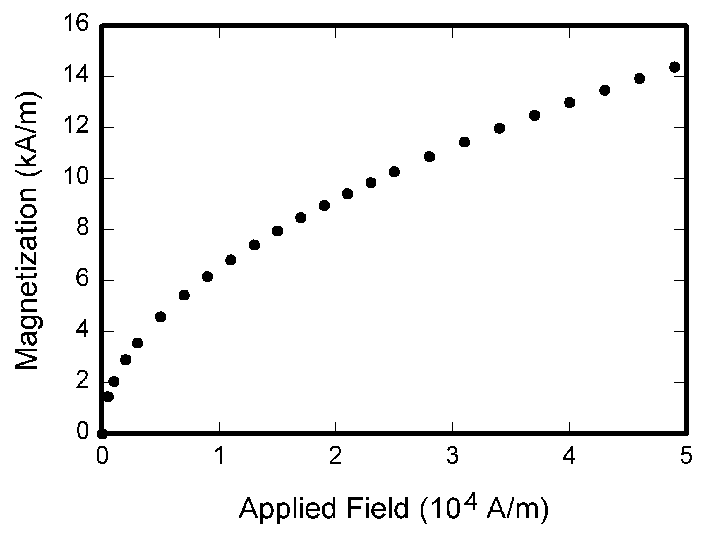

Fig. 1. Magnetization as a function of applied field. Note that “Fig.” is abbreviated.

## Resolution

The proper resolution of your figures will depend on the type of figure it is as defined in the “Types of Figures” section. Author photographs, color, and grayscale figures should be at least 300dpi. Lineart, including tables should be a minimum of 600dpi.

## Color Space

The term color space refers to the entire sum of colors that can be represented within the said medium. For our purposes, the three main color spaces are Grayscale, RGB (red/green/blue) and CMYK (cyan/magenta/yellow/black). RGB is generally used with on-screen graphics, whereas CMYK is used for printing purposes.

All color figures should be generated in RGB or CMYK color space. Grayscale images should be submitted in Grayscale color space. Line art may be provided in grayscale OR bitmap colorspace. Note that “bitmap colorspace” and “bitmap file format” are not the same thing. When bitmap color space is selected, .TIF/.TIFF is the recommended file format.

## Accepted Fonts Within Figures

When preparing your graphics suggests that you use of one of the following Open Type fonts: Times New Roman, Helvetica, Arial, Cambria, and Symbol. If you are supplying EPS, PS, or PDF files all fonts must be embedded. Some fonts may only be native to your operating system; without the fonts embedded, parts of the graphic may be distorted or missing.

A safe option when finalizing your figures is to strip out the fonts before you save the files, creating “outline” type. This converts fonts to artwork what will appear uniformly on any screen.

## Referencing a Figure or Table Within Your Paper

When referencing your figures and tables within your paper, use the abbreviation “Fig.” even at the beginning of a sentence. Do not abbreviate “Table.” Tables should be numbered with Roman Numerals..

# **Conclusion**

A conclusion section is not required. Although a conclusion may review the main points of the paper, do not replicate the abstract as the conclusion. A conclusion might elaborate on the importance of the work or suggest applications and extensions.

**Appendix**

Appendixes, if needed, appear before the acknowledgment.

**Acknowledgment**

The preferred spelling of the word “acknowledgment” in American English is without an “e” after the “g.” Use the singular heading even if you have many acknowledgments. Avoid expressions such as “One of us (S.B.A.) would like to thank ... .” Instead, write “ Author S. M. thanks ... .” In most cases, sponsor and financial support acknowledgments are placed in the unnumbered footnote on the first page, not here.

**References**

[1]. Author, K. L., and Author, B. M.: ‘*Title of the Journal Paper*’,Name of the journal, Year, v, (n), pp. xxx-xxx

[2]. Author, C. P., Author, D. G., and Author, F.O.: ‘*Title of the Conference Paper*’, Name of the conference, Country, Year, pp. xxx-xxx.

[3]. Author, M. E.: ‘*Title of the Book Chapter*’, Title of Published Book, xth ed. City of Publisher, Country, Publisher, ch.x, sec. x, Year, pp. xxx–xxx.

[4]. Author, J. P.: ‘*Title of the Thesis*’, MSc Thesis, Name of the University, Country, Year.

[5]. Author F. J.: ‘*Title of Patent*’, U.S. Patent x xxx xxx, Abbrev. Month, day, Year.

[6]. Shridhar, R., and Cooper, D.J.: ‘A Tuning Strategy for Unconstrained SISO Model Predictive Control’, Industrial & Engineering Chemistry Research, 1997, 36, (3), pp. 729-746

[7]. Emhemed, A. A. A., Mamat, R., Faudzi, A. A. M., Johary, M. R., and Osman, K.: *Modified Predictive Control for a Class of Electro-Hydraulic Actuator.* International Journal of Electrical and Computer Engineering (IJECE), 2016, 6, (2), 630-638

[8]. Emhemed, A.A.A., Mamat, R., and Faudzi, A.A.M.: ‘A New Predictive Control Technique for Force Control of Pneumatic Actuator Plant’, 10th Asian Control Conference (ASCC2015), Malaysia, 2015, pp. 1-6

[9]. Dorf, R. C., and Bishop, R. H.: *Modern Control Systems*. 12th edition. Prentice Hall.‏ 2011

[10]. Thømt, A. C.: *Investigation, Dimensions and Development of Test Setup for Propulsion Function of a Personal Transport Drone.* M.Sc Thesis, Norwegian University of Life Sciences, Norway, 2017.‏

**First A. Author1** and the other authors may include biographies at the end of regular papers. The first paragraph may contain a place and/or date of birth (list place, then date). Next, the author’s educational background is listed. The degrees should be listed with type of degree in what field, which institution, city, state or country, and year degree was earned. The author’s major field of study should be lower-cased. The second paragraph uses the pronoun of the person (he or she) and not the author’s last name. It lists military and work experience, including summer and fellowship jobs. Job titles are capitalized. The current job must have a location; previous positions may be listed without one. Information concerning previous publications may be included. The third paragraph begins with the author’s title and last name (e.g., Dr. Smith, Prof. Jones, Mr. Kajor, Ms. Hunter). List any memberships in professional societies other than the IEEE. Finally, list any awards and work for IEEE committees and publications. If a photograph is provided, the biography will be indented around it. The photograph is placed at the top left of the biography. Personal hobbies will be deleted from the biography.

**Second B. Author2** (M’12) was born in City, Country. He received the M. degree in electrical engineering from University of City, Country in 2012.

The second paragraph uses the pronoun of the person (he or she) and not the author’s last name. It lists military and work experience, including similar information to the previous author, including military, work experience, and other jobs. Job titles are capitalized.

1. ¹F.A.Authors’ affiliation: xxx Department, University of xxx, City, State C.P. Country, on leave from the National Institute for xxx, City, Country

   ²S.B.Authors’ affiliation: xxx Department, University of xxx, City, State C.P. Country, on leave from the National Institute for xxx, City, Country

   ³T. C. Author is with the National Institute of xxx, City, State C.P. Country

   E-mail: author@ domain.edu.gov¹